Generative AI

Index

S.No | Topic | Pg No
1 | What is generative AI?
2 | Types of data in generative AI
3 | Use cases

What is Generative AI ?

Generative AI is a type of artificial intelligence designed to create new content such as text, images, music or even code by learning patterns from existing data. These models generate original outputs that are often indistinguishable from human-created content. These models use techniques like deep learning and neural networks to generate output. Unlike discriminative AI which focuses on classifying data into categories like spam vs. not spam, generative AI creates new data such as text, images, audio or video that resembles real-world examples.

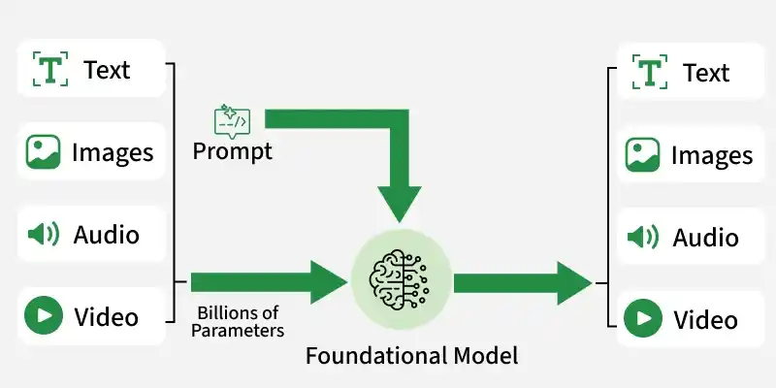

Core Mechanism : Generative AI is trained on large datasets like text, images, audio or video using deep learning networks. During training, the model learns parameters (millions or billions of them) that help them predict or generate content. Here models generate output based on learned patterns and prompts provided

Types of Generative AI Models

1. Transformers or Autoregressive Models :
- Autoregressive Transformer Models generate sequences by predicting the next token based on preceding tokens. The architecture utilizes the transformer’s self-attention mechanism to effectively capture context from the entire input.
- This method is highly effective for natural language and code generation. The autoregressive approach allows fine-grained control over each output step.
- However, it can be slower for long generations as tokens are produced one at a time (e.g., GPT).

2. Diffusion Models
- Diffusion models generate data (images/audio) from random noise, refining it through denoising steps. Each step reverses a simulated diffusion process that adds noise to real data during training.
- This iterative method produces detailed and realistic results, particularly in image synthesis, with benchmarks set by models like Stable Diffusion and DALL·E 3.
- Diffusion models are versatile and can be adapted for inpainting, style transfer, and conditional generation from text prompts.

3. Variational Autoencoders (VAEs) and Generative Adversarial Networks (GANs)
- VAEs (Variational Autoencoders) and GANs (Generative Adversarial Networks) are foundational deep learning architectures for generative tasks.
- VAEs encode data into a compressed latent space and decode it with a probabilistic approach, promoting smooth and continuous representations beneficial for controllable generation and style interpolation.
- GANs consist of two competing networks: a generator that creates realistic outputs and a discriminator that identifies fake outputs.
- This adversarial training process results in realistic, sharp images, although it can lead to instability and mode collapse during training.

4. Encoder Decoder Models
- Encoder decoder architectures consist of two stages: the encoder processes the input into a dense representation and the decoder generates the desired output from that representation.
- They are widely used for sequence to sequence tasks like language translation, summarization and image captioning.
- The encoder captures the full context of the input before the decoder starts producing tokens, allowing for strong performance on tasks that require global understanding rather than token by token prediction.

Types of Data in Generative AI
- Text: Uses large language models (LLMs) to predict the next token in a sequence, enabling coherent paragraph or essay generation.
- Images: Diffusion models like DALL·E or Stable Diffusion start with noise and iteratively denoise to create realistic visuals
- Speech: Text-to-speech models synthesize human-like voice by modeling acoustic features based on prompt.
- Video: Multimodal systems like Sora by OpenAI or Runway generate short, temporally coherent video clips from text or other prompts

Output type | How it works | What it generates
Text generators | Learns patterns in large text datasets and predicts the next words to produce coherent text | Emails, summaries, answers, scripts, long-form content
Image generators | Learns visual patterns from large image datasets and maps text prompts to images | Visuals from prompts, concept art, marketing creatives, design variations
Audio and voice generators | Learns pronunciation, tone, and rhythm from audio data to produce speech from text or a voice sample | Speech, voiceovers, synthetic voices, spoken audio
Video generators | Generates a sequence of frames while trying to keep subject and scene continuity | Short clips, animations, prompt-based scenes
Code generators | Learns syntax and programming patterns from code corpora to suggest or generate working code | Code snippets, functions, tests, refactors

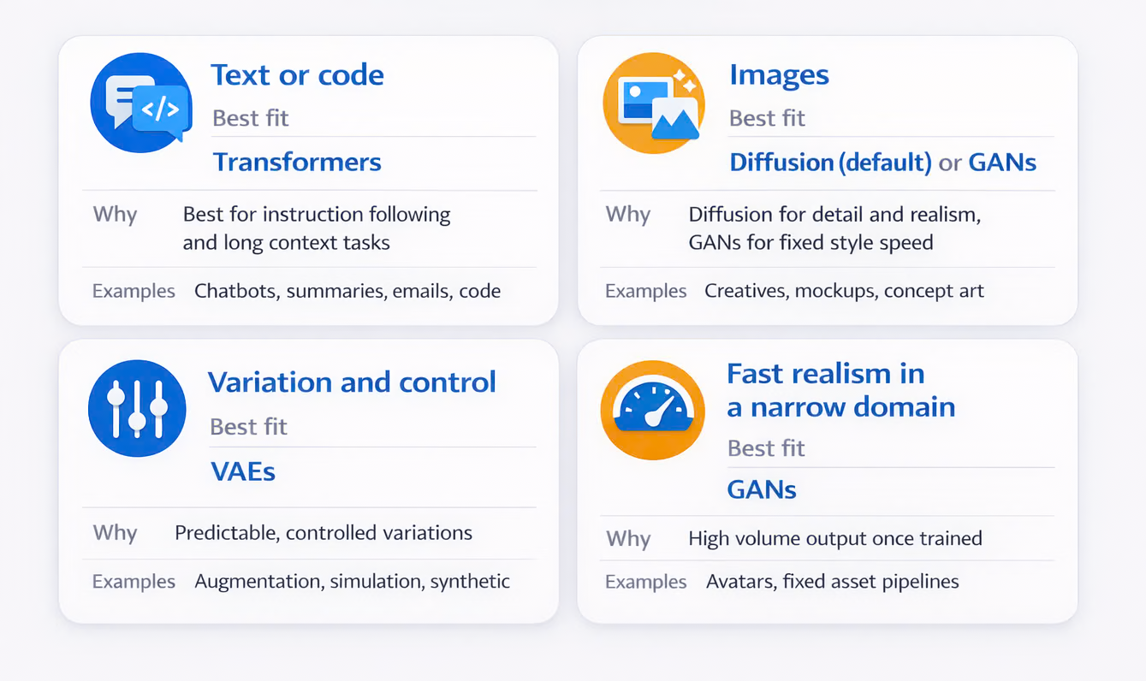
Use cases for Each Type of Data
- Text Generation: Writing articles, stories, poetry, and reports. Tools like GPT-4 can assist in drafting content, generating creative writing, and even producing news articles.
- Image Generation: Creating digital art, designing graphics, and producing marketing materials. AI models like DALL-E can generate high-quality images from textual descriptions.
- Music Composition: Composing original music, creating background scores for videos, and generating sound effects.
- Video Generation: Producing video content, generating animations, and enhancing video editing processes.

